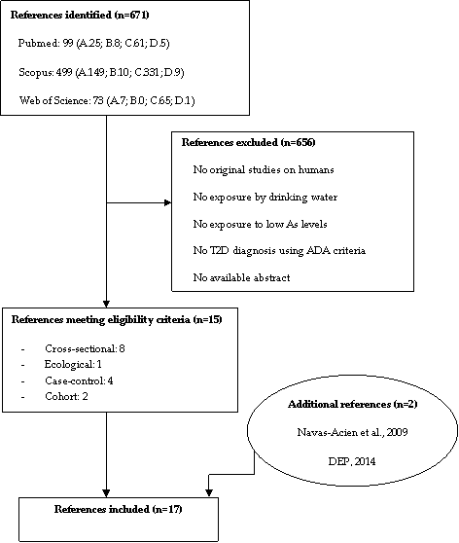
Selection keywords: A. “arsenic*”AND “diabetes” as Mesh term AND “low”; B. “arsenic*”AND “T2D” as Mesh term AND “low”; C. “arsenic*”AND “diabetes” as Mesh term NOT “low”; D. “arsenic*”AND “T2D” as Mesh term NOT “low”.

Figure 1. Flow chart of epidemiologic study selection process

