1. **Table 1: Baseline characteristics of the patients of the studies considered for the meta-analysis.**

|  |  |  |  |  |  |  |  |  |  |  |
| --- | --- | --- | --- | --- | --- | --- | --- | --- | --- | --- |
| **First author** | **Year of publication** | **Country** | **Sample size** | **Population** | **Convalescent plasma (intervention arm)** | **Placebo or standard treatment alone or control** | **Death Intervention arm** | **Death Control arm** | **Invasive ventilation intervention arm** | **Invasive ventilation control arm** |
| **Simonovich** | **2020** | **Argentina** | **333** | **severe disease** | **228** | **105** | **25** | **12** | **19** | **10** |
| **Agarval** | **2020** | **India** | **451** | **moderate disease** | **227** | **224** | **44** | **41** | **19** | **19** |
| **Li** | **2020** | **China** | **103** | **severe and life threatening disease** | **52** | **51** | **8** | **12** | **14** | **11** |
| **Rasheed** | **2020** | **Iraq** | **49** | **life threatening disease** | **21** | **28** | **1** | **8** | **17** | **16** |
| **Abolghasemi** | **2020** | **Iran** | **189** | **moderate -severe disease** | **115** | **74** | **17** | **18** | **8** | **15** |
| **Xia** | **2020** | **China** | **1568** | **severe and life threatening disease** | **138** | **1430** | **3** | **59** | **2** | **3** |

**Table 2. Test of residual heterogeneity**

**Forest Plots**

|  |  |  |  |  |  |  |
| --- | --- | --- | --- | --- | --- | --- |
| **Fixed and Random Effects** | | | | | | |
|  | | **Q** | | **df** | | **p** |
| **Omnibus test of Model Coefficients** |  | **2.098** |  | **1** |  | **0.147** |
| **Test of Residual Heterogeneity** |  | **6.501** |  | **5** |  | **0.261** |
|  | | | | | | |
| ***Note.*   *p* -values are approximate.** | | | | | | |

**Figure 1. Forest plot, mortality among groups, FE model: fixed effect model**

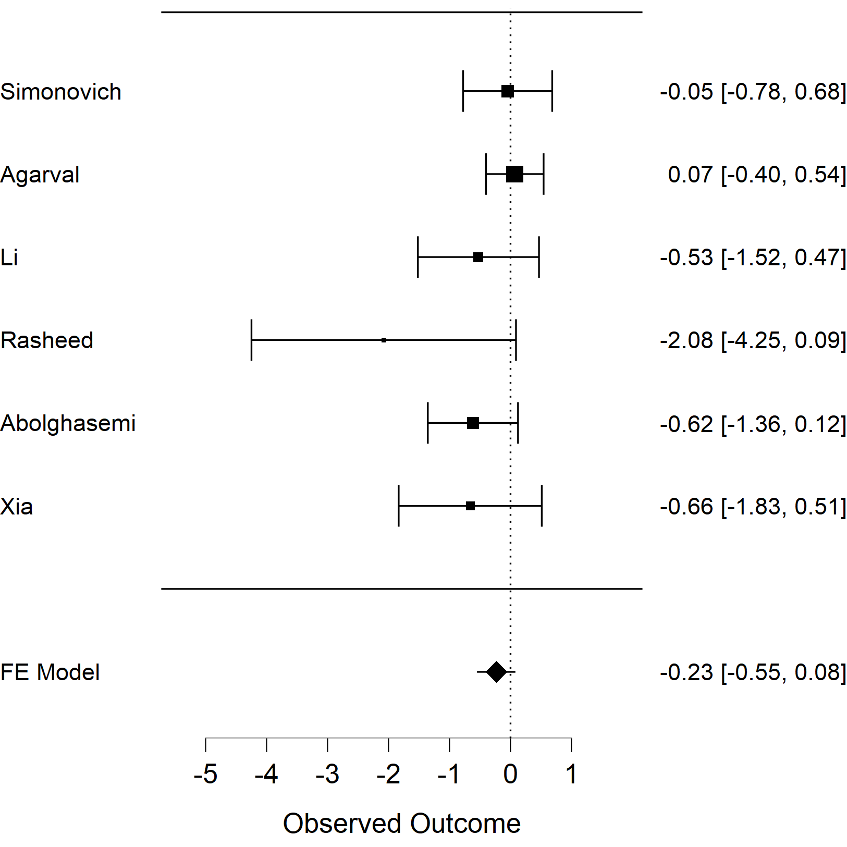

**Table 3. Wald Test, Intercept -0,232[-0,546- 0,082], p 0,147**

|  |  |  |  |  |  |  |  |  |  |  |  |  |  |
| --- | --- | --- | --- | --- | --- | --- | --- | --- | --- | --- | --- | --- | --- |
| **Coefficients** | | | | | | | | | | | | | |
|  | | | | | | | | | | **95% Confidence Interval** | | | |
|  | | **Estimate** | | **Standard Error** | | **z** | | **p** | | **Lower** | | **Upper** | |
| **intercept** |  | **-0.232** |  | **0.160** |  | **-1.449** |  | **0.147** |  | **-0.546** |  | **0.082** |  |
|  | | | | | | | | | | | | | |
| ***Note.*  Wald test.** | | | | | | | | | | | | | |

**Figure 2. Forest plot of invasive ventilation need**



**Figure 3. Funnel plot of mortality.**

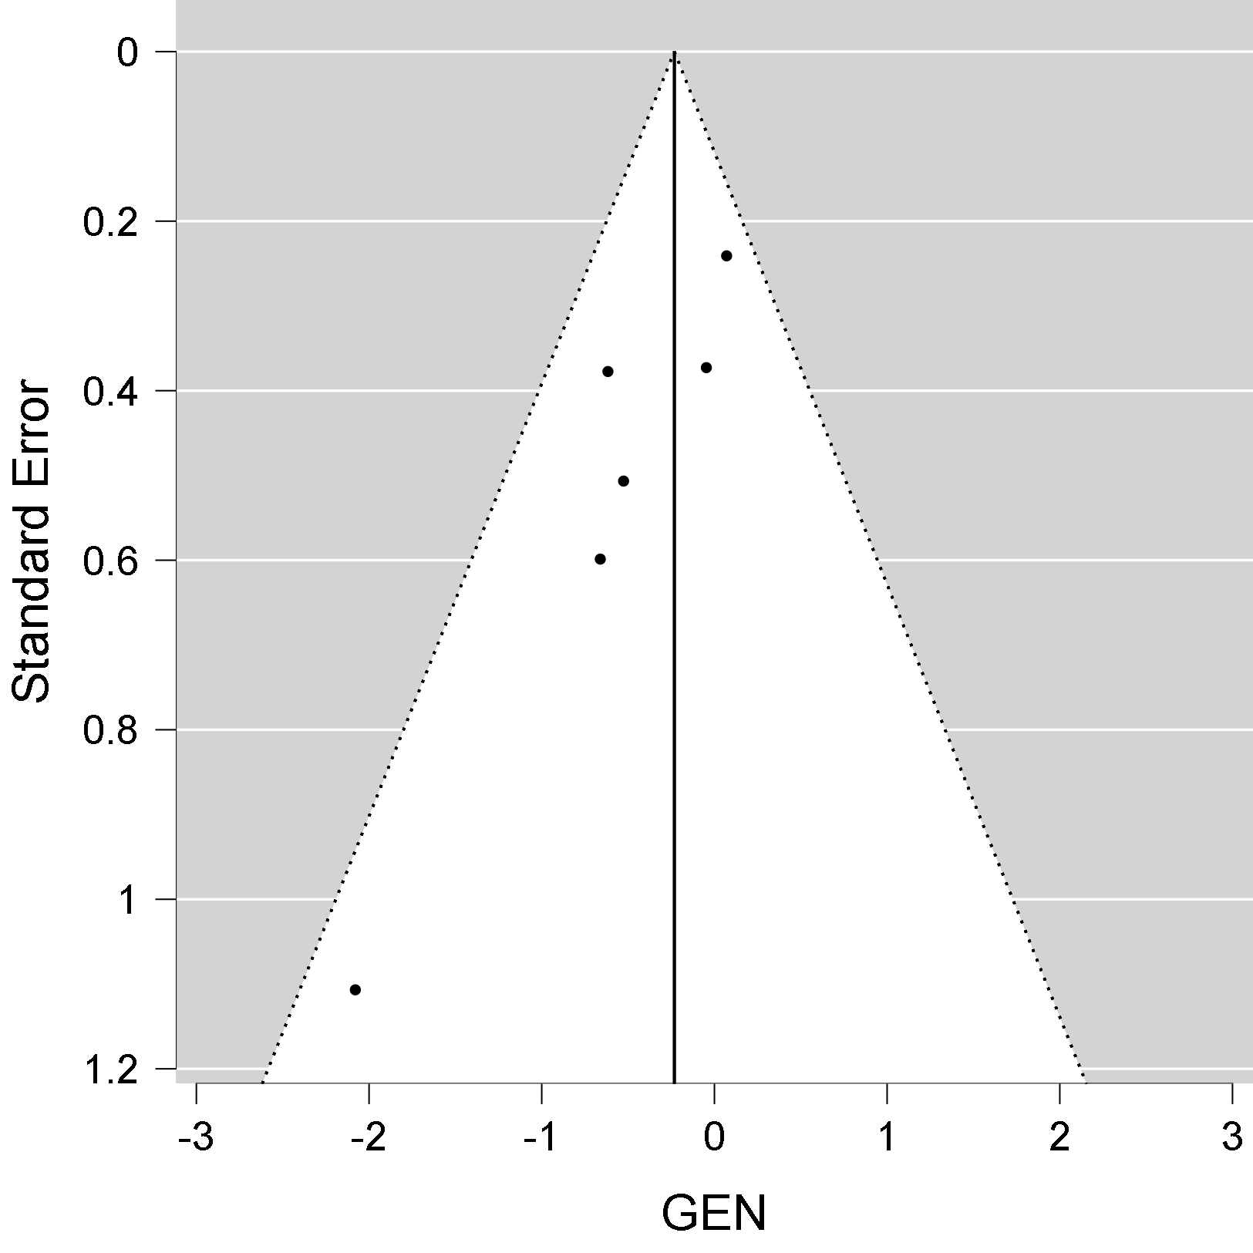

**Table 4. Egger's test**

|  |  |  |  |  |  |
| --- | --- | --- | --- | --- | --- |
| **Regression test for Funnel plot asymmetry ("Egger's test")** | | | | | |
|  | | **z** | | **p** | |
| **sei** |  | **-2.294** |  | **0.022** |  |
|  | | | | | |

**Figure 4. Funnel plot of invasive ventilation.**

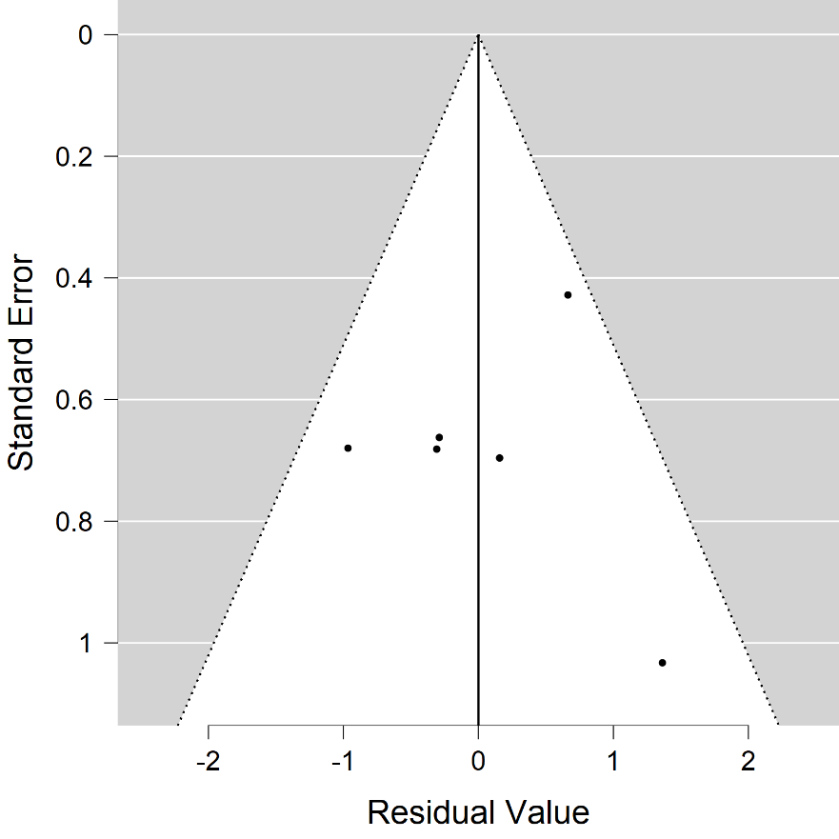

**Table 5. Egger's test for the invasive ventilation**

| **Regression test for Funnel plot asymmetry ("Egger's test")** | | | | | |
| --- | --- | --- | --- | --- | --- |
|  | | **z** | | **p** | |
| sei |  | 1.095 |  | 0.274 |  |
|  | | | | | |